The implementation of this tool is not mandatory. The tool contains recommendations to support workplace violence prevention and regulatory compliance. The information presented can be adopted in whole, in part, or not at all.

Revision: 1.0, date: 2021-06-02
Workplace Violence Risk Assessment
A template for K-12 Public education - compliance

Terms of use
By accessing or using these BCPSEA posted resource materials, you agree to be bound by these terms and conditions.

Content: Although BCPSEA endeavors to ensure that the information provided within these resource materials is as accurate, complete and current as possible, BCPSEA makes no representations or warranties about the information, including in respect of its accuracy, completeness or currency. BCPSEA assumes no responsibility for any loss or damage to you or any other person, howsoever caused, that is in any way related to the information found within these resource materials or your use of it.

Intent: The content within these resource materials is provided for educational and general informational purposes. It should not be considered as solicitation, endorsement, suggestion, advice or recommendation to use, rely on, exploit or otherwise apply such information or services.

Introduction

The following Workplace Violence Risk Assessment (WVRA) has been reviewed by the site joint health and safety committee or worker representative. The WVRA includes locations and circumstances at the school district location identified in the table below. The WVRA is made available for review to all workers and must be maintained to reflect any changes to the workplace. The purpose of the risk assessment is to ensure that the employer has evaluated the risk of workplace violence. When necessary, procedures, policies, and work arrangements, are implemented to eliminate the hazard of workplace violence or when elimination is not possible minimize the risk to workers.

Background

As required by section 4.28 of the Occupational Health and Safety Regulation of British Columbia, any workplace where there is a potential for risk of injury to workers from violence arising out of their employment must conduct a workplace violence risk assessment. The risk assessment must take into consideration: the previous workplace violence experiences in that workplace, occupational experience in similar workplaces, and the location and circumstances where work takes place.
School districts must ensure that a risk assessment is completed for each individual work location, and considers the entire work location as well as the work circumstances for all workers of that location, including casual workers. For the K-12 public education sector, site based risk assessments should include but not be limited to schools, district offices, trade shops, bus depots, mobile workforce, working alone, home visits, working with the public, and working with students.

Site Description

Site Name:
Address:
Hours of operation and number of workers at each time: | Monday-Friday Yes, No | Weekends Yes, No
 | Days 6AM-5PM, # of emp.  Evenings 5PM-12AM, # of emp.  Overnight 12AM-6AM, #of emp. | Days 6AM-5PM, # of emp.  Evenings 5PM-12AM, # of emp.  Overnight 12AM-6AM, #of emp.
Site purpose(check the appropriate box): | Elementary School Middle School Secondary School Office Building Trade shop  Other:
Site Description (setting location, type of building, other buildings on property, parking, access):
Last significant operational or structural changes at the site (list most recent significant changes): |  |  | Date:
 |  |  | Date:
 |  |  | Date:
Full names and roles of team members involved in this risk assessment:
Initial Risk Assessment Date:
Last Review Date
Last Revision Date

Consideration for Experiences

Quantitative Site Based Experiences [4.28(2)a]
The table below includes data on the site specific frequency of the experiences related to workplace violence over the last three (3) years based upon workplace violence incident reports.
Option 1 (total incidents grouped together – delete this line and table if not used)
Workplace Violence Type | 20XX/20XX[most recent] | 20XX/20XX | 20XX/20XX
Total Incidents
All incidents of workplace violence

Option 2 (incidents broken down into type – delete this line and table if not used)
Workplace Violence Type | 20XX/20XX[most recent] | 20XX/20XX | 20XX/20XX
Type I - Criminal
No legitimate relationship to the school district or its workers
Type II – Customer/Client (total)
Parents and family members, students, or contractor/visitors,
Type IIa – Parents/Guardians
Type IIb - Students
Type IIc – contractors/visitors
Type III - Worker on Worker  Worker of the organization who attacks or threatens other worker(s)* | N/A | N/A | N/A

Type IV - Personal Relationship
Personal relationship with the intended victim, no association with work – domestic violence.
*Worker to Worker violence occurrences are not currently covered by the definition of Workplace Violence under section 4.27. Inappropriate Worker to Worker behaviour is covered under OHSR section 4.25.

Qualitative Site Based Experiences [4.28(2)a]
The table below includes a summary of the data on the worker experience at the site gained through the latest workplace violence experience surveys.
Question | 20XX/20XX  [most recent] | 20XX/20XX | 20XX/20XX
Have you experienced workplace violence (contact or non-contact) in the last year? | Yes  No | Yes  No | Yes  No
Have you submitted a report for a workplace violence incident in the last year? | Yes  No | Yes  No | Yes  No
Have you personally been involved in the workplace violence process at the site?  (This could include: risk assessment participation, reviewing reports, part of a review team, acknowledging Individual Safe Work Instructions, supporting during a response, reviewing procedures. Excludes incident reporting or being injured during an incident.) | Yes  No | Yes  No | Yes  No
I believe that internal processes and approaches on managing workplace violence are;  Improving?  Staying the same?  Declining? | Improving  Staying the same  Declining | Improving  Staying the same  Declining | Improving  Staying the same  Declining
When was the last time you participated in training/awareness initiatives related to improving your knowledge and understanding of workplace violence prevention?
Less than 2 years ago?
Between 2-3 years ago?
More than 3 years ago?
Overall summary of comments on workplace violence (highlight themes or comments).

Similar Workplaces and Sector Based Experiences [4.28(2)b]

The table below outlines the consideration of experiences from a similar workplace
Similar Site Name:
Address:
Hours of operation and number of workers at each time: | Monday-Friday Yes, No | Weekends Yes, No
 | Days 6AM-5PM, # of emp.  Evenings 5PM-12AM, # of emp.  Overnight 12AM-6AM, #of emp. | Days 6AM-5PM, # of emp.  Evenings 5PM-12AM, # of emp.  Overnight 12AM-6AM, #of emp.
Site purpose(check the appropriate box): | Elementary School Middle School Secondary School Office Building Trade shop  Other:
Site Description (setting location, type of building, other buildings on property, parking, access):
Has the similar site identified risks that were not previously considered at your site? | Yes, No,  Comments:
How does the summary of quantitative and qualitative experiences at the similar site compare to your site?
Is there anything you will plan to change based on this comparison to the similar site? | Yes, No,  Comments:

School districts operate in very similar formats across the province of British Columbia. Although the buildings, geographic locations and the number of students or workers may be different at each site, the experiences of the sector as a whole can be representative of each district and for the most part each site. The figures below are available through WorkSafeBC and give a provincial level view on the numbers of workplace violence cases resulting in claims and is representative to the sector over a period of time [during the review of the risk assessment sites should look to ensure they have the latest information from WorkSafeBC]. Workers and Managers should use this information to recognize the issue of workplace violence exists in the K-12 education sector even if they as an individual site, or as a district are not experiencing the same specific issues at the time of their site risk assessment.
The following information, pulled from the WSBC website in the spring of 2021, represents all workplaces in the education sector for the five-year period between 2015 and 2020.
- Violence incidents are the 4th largest claim incident type.
- There were 1324 time-loss incidents related to workplace violence in the education sector over that period.
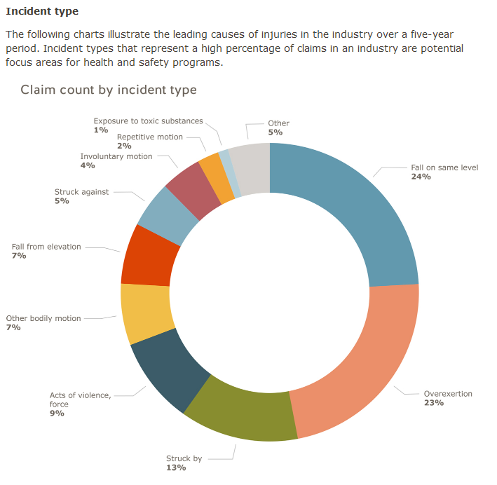
Source: https://www.worksafebc.com/en/health-safety/industries/education/statistics
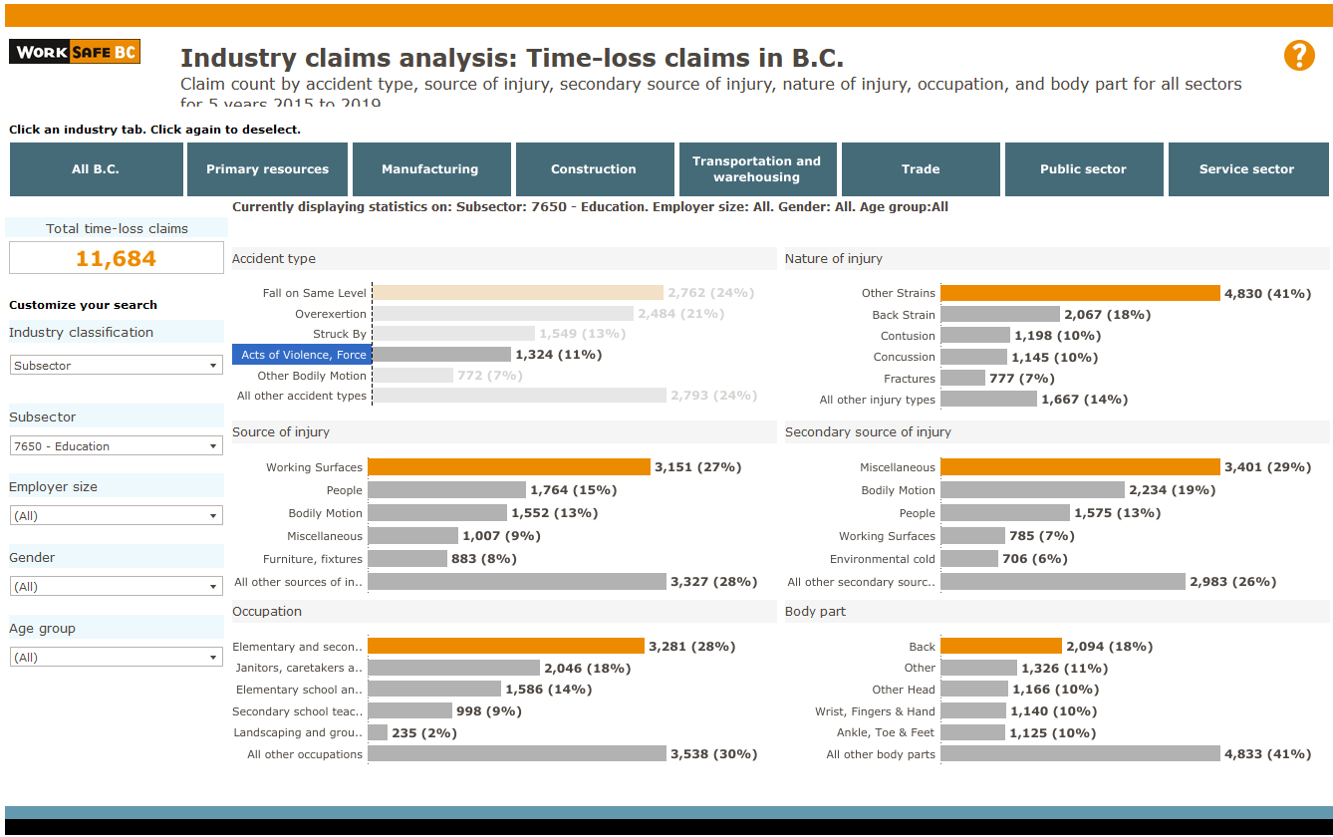
Source: https://public.tableau.com/profile/worksafebc#!/vizhome/IndustryclaimsanalysisTime-lossclaimsinB_C_/Didyouknow

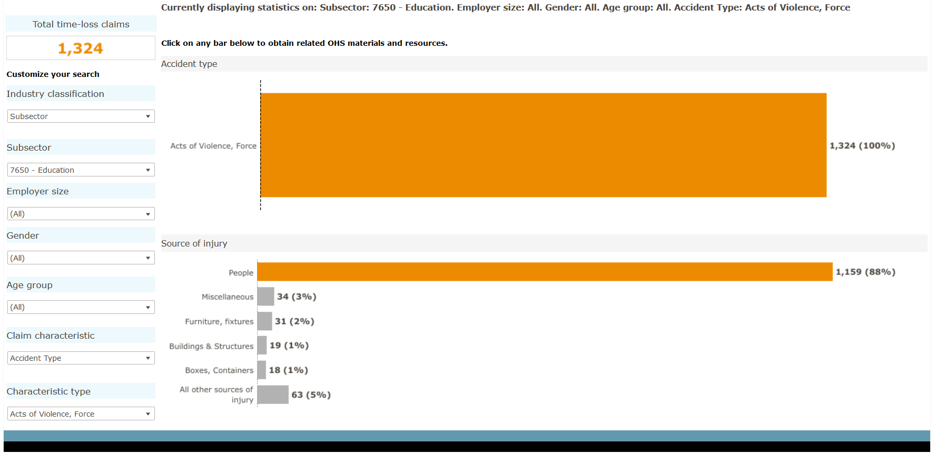

Source: https://public.tableau.com/profile/worksafebc#!/vizhome/IndustryclaimsanalysisTime-lossclaimsinB_C_/Didyouknow

Locations and Circumstances [4.28(2)c]
Workplace Violence Risk Assessment Rating Tool
The following risk assessment rating tool is used to quantitatively evaluate the conditions or setting of the workplace so that the higher risk items can be easily identified. As much as reasonably practicable, the conditions and setting with the higher rating should be prioritized for actions to reduce the risk score.

Risk Assessment Rating Descriptions
 | Low | Medium | High | Extreme
Severity  Physical/psychological injury severity potential | (1 pt)  Minor first aid treated at the site | (2 pts)  Medical aid – healthcare professional required | (3 pts)  Health care professional treatment and lost time >5 days | (4 pts)  Health care professional treatment resulting in permanent disability
Probability  Probability of an incident based on the current situation | (1 pt)  Not possible or probable | (2 pts)  Might happen in the future but not certain when | (3 pts)  Will happen today or tomorrow if work proceeds as planned | (4 pts)  Will happen immediately if work proceeds as directed
Control measures  Existing control measures to support safe work | (1 pt)  Controls in place, workers are aware, experienced, skilled, and have authority to address issue effectively | (2 pts)  Limited controls in place, workers are aware, but with limited experience or skills, and cannot address the issue without additional support | (3 pts)  No controls in place, limited worker hazard awareness, skills and experience are limited | (4 pts)  No controls, no worker hazard awareness, no experience, young worker

Risk Score
Risk Score = S*P*C | Severity (pts) | * | Probability (pts) | * | Controls  (pts) | = | Total Risk Score

Risk Level | Risk Score Range | Expected actions
Low risk | 1-7 | Could proceed as planned; the issue is not likely to lead to increased risk of injury.
Med risk | 8-16 | Could proceed but need to reconsider the context and the controls to manage risk.
High risk | 18-64 | Must review the work as planned and reduce risk by implementing controls.

Location Based Risks
The following are this site’s location-based risks. [items in the table below can be found in the risk assessment excel workbook on the worksheet titled “Print or copy RA table” – filter that worksheet for “Locations” and paste the information into the table below]
Work Condition or Setting | Area of Risk | Type of Violence (hazard source) | Those potentially affected | Severity Rating  (1-4) | Probability Rating  (1-4) | Controls Rating  (1-4) | Total Risk Score | Types of Controls In Place | Description of Controls | Action Required | Last Review Date
Parking Lots | Location | All Types | All Workers | TBD | TBD | TBD | TBD | TBD | TBD | TBD | TBD
Building Interior | Location | All Types | All Workers | TBD | TBD | TBD | TBD | TBD | TBD | TBD | TBD
Surrounding Community | Location | Type I, Type II | All Workers | TBD | TBD | TBD | TBD | TBD | TBD | TBD | TBD
Access points | Location | All Types | All Workers | TBD | TBD | TBD | TBD | TBD | TBD | TBD | TBD
Members of the public known or unknown at reception | Location | Type I, Type II | Child and Youth Worker, Manager, Office Staff, Principal/Vice Principal | TBD | TBD | TBD | TBD | TBD | TBD | TBD | TBD
Learning spaces | Location | Type I | Child and Youth Worker, Counselor/Specialist, Educational Assistant, Principal/Vice Principal, Teacher | TBD | TBD | TBD | TBD | TBD | TBD | TBD | TBD
Portable Teaching Units | Location | Type I, Type II | Child and Youth Worker, Educational Assistant, Teacher | TBD | TBD | TBD | TBD | TBD | TBD | TBD | TBD
Trade shops, Bus depots, Storage lots | Location | Type I, Type II | Custodians, Driver, Manager, Office Staff, Trades Persons | TBD | TBD | TBD | TBD | TBD | TBD | TBD | TBD
TBD = to be determined by the school district and site.

Circumstance Based Risks
The following are this site’s circumstance based risks. [items in the table below can be found in the risk assessment excel workbook on the worksheet titled “Print or copy RA table” – filter that worksheet for “Circumstances” and paste the information into the table below]
Work Condition or Setting | Area of Risk | Type of Violence (hazard source) | Those potentially affected | Severity Rating  (1-4) | Probability Rating  (1-4) | Controls Rating  (1-4) | Total Risk Score | Types of Controls In Place | Description of Controls | Action Required | Last Review Date
Buses and Car Transportation | Circumstance | Type I, Type II | Child and Youth Worker, Driver, Educational Assistant | TBD | TBD | TBD | TBD | TBD | TBD | TBD | TBD
Student dysregulation | Circumstance | Type II | Child and Youth Worker, Driver, Educational Assistant, Principal/Vice Principal, Teacher | TBD | TBD | TBD | TBD | TBD | TBD | TBD | TBD
Home visits | Circumstance | Type II | Child and Youth Worker, Counselor/Specialist, Educational Assistant | TBD | TBD | TBD | TBD | TBD | TBD | TBD | TBD
Transporting students | Circumstance | Type II | Child and Youth Worker, Driver, Educational Assistant | TBD | TBD | TBD | TBD | TBD | TBD | TBD | TBD
Student worrisome behaviour | Circumstance | Type II | All Workers | TBD | TBD | TBD | TBD | TBD | TBD | TBD | TBD
Contact with parents or guardians | Circumstance | Type II | Child and Youth Worker, Principal/Vice Principal, Reception, Teacher | TBD | TBD | TBD | TBD | TBD | TBD | TBD | TBD
Contact with members of the public unknown | Circumstance | Type I | Child and Youth Worker, Educational Assistant, Executive, Office Staff, Principal/Vice Principal, Reception, Supervision Aid, Teacher | TBD | TBD | TBD | TBD | TBD | TBD | TBD | TBD
Field trips | Circumstance | Type I, Type II | Child and Youth Worker, Educational Assistant, Teacher | TBD | TBD | TBD | TBD | TBD | TBD | TBD | TBD
Facility Renters | Circumstance | Type II | Custodians, Manager | TBD | TBD | TBD | TBD | TBD | TBD | TBD | TBD
Contractors | Circumstance | Type II | Manager, Principal/Vice Principal, Trades Persons | TBD | TBD | TBD | TBD | TBD | TBD | TBD | TBD
Working alone | Circumstance | Type II, Type IV | Child and Youth Worker, Custodians, Teacher, Trades Persons | TBD | TBD | TBD | TBD | TBD | TBD | TBD | TBD
Intervening in student to student physical conflict | Circumstance | Type II | Educational Assistant, Principal/Vice Principal, Supervision Aid, Teacher | TBD | TBD | TBD | TBD | TBD | TBD | TBD | TBD
Handling cash - during events, or routine transactions | Circumstance | Type I, Type II | Office Staff, Principal/Vice Principal, Reception | TBD | TBD | TBD | TBD | TBD | TBD | TBD | TBD
Night school | Circumstance | Type I, Type II, Type IV | Custodians, Principal/Vice Principal, Teacher | TBD | TBD | TBD | TBD | TBD | TBD | TBD | TBD
Public meetings | Circumstance | Type I, Type II, Type IV | Custodians, Executive, Manager, Office Staff, Principal/Vice Principal, Reception, Teacher | TBD | TBD | TBD | TBD | TBD | TBD | TBD | TBD
Working from home | Circumstance | Type IV | Counselor/Specialist, Educational Assistant, Executive, Manager, Office Staff, Teacher | TBD | TBD | TBD | TBD | TBD | TBD | TBD | TBD
Personal care - peri-care | Circumstance | Type II | Educational Assistant | TBD | TBD | TBD | TBD | TBD | TBD | TBD | TBD
Off site community based learning | Circumstance | Type I, Type II | Child and Youth Worker, Educational Assistant, Teacher | TBD | TBD | TBD | TBD | TBD | TBD | TBD | TBD
TBD = to be determined by the school district and site.

Action Plan to address the most significant risks for workplace violence
[items targeted for reduction must be added to this action plan list and reviewed periodically to ensure they are completed as planned – this information can be found in the risk assessment excel workbook – filter the Actions Table worksheet for “Action Required = Yes, and paste the information into the table below]

Work Condition or Setting | Total Risk Score | Action Required | Action Plan | Responsible Person | Action Plan Status Update | Target Date | Last Review Date
TBD | TBD | TBD | TBD | TBD | TBD | TBD | TBD
TBD | TBD | TBD | TBD | TBD | TBD | TBD | TBD
TBD | TBD | TBD | TBD | TBD | TBD | TBD | TBD
TBD | TBD | TBD | TBD | TBD | TBD | TBD | TBD
TBD = to be determined by the school district and site.

End of report

